Ask and it shall be given you; seek and ye shall
find; knock and it shall be opened unto you.
Matthew 7:7
Have you ever asked God for something and it seemed like there was no answer? That has happened to me. Sometimes the answer was gradually revealed through events, and God’s hand was seen in small details. Those times have increased my trust, knowing my Heavenly Father is working out His good will in my life
even when I do not see the answers clearly.
I hoped to return to Haiti and the Grace Baptist Clinic earlier this year. However, there were some questions that needed to be settled first. As a result, I was here in the States when my mother died unexpectedly at the end of March. I was able to travel to Lansing, Michigan, and stay with my sister. The scheduled meetings I attended in the north meant extra time to help her before returning to Greenville, South
Carolina, in May.
It always encourages me when people say they are praying for my safety as I travel. God gave me a safe 15-hour drive from Lansing to New Hampshire for the Spring Meeting of Baptist World Mission. I am often reminded that God could put an “accident” in my life, and I have wondered how many times the prayers of
God’s people directly affected my paths.
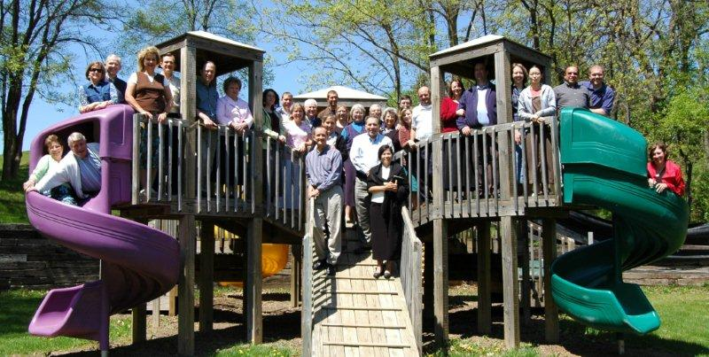
Baptist World Mission accepted me as an appointee to Haiti on April 20. Since then, there has been much new material to absorb. Orientation Week at Camp Joy, Wisconsin, provided a lot more information. It also gave time to get to know the administrators and their wives, staff members and other missionaries.
I plan to travel to Haiti on June 3 and stay until the end of September, as our Lord wills. The Haitian staff at the clinic wants me to return and so do the patients and people in the area. In addition to working in the clinic, I need to take care of details for the property, hold meetings with the staff and pray with them, and meet with the man who can give direction concerning non-profit status. The Pearts are returning to the States for furlough on June 10 and would like me to stay in their house at least
part of the time while they are gone.
Praise I am grateful to my church for renting a vehicle for my six-week stay in the north.
It was great to see Nate and Amy Copeland. Nate came to the clinic for the summer of 2005. He is now in medical school in Chicago.
Prayer Tim and RoseAnne Bower and their family will be in the States for part of June. Please pray for Tim as he deals with some challenges that have come up in the past few months.
It would be so easy to get “swamped” with all that needs to be done in the next few months. Please pray that I will have wisdom to use my
time wisely in God’s service.
Recently I came across the following, written by John Newton:
Thou art coming to a King
Large petitions with thee bring:
For his grace and power are such,
None can ever ask too much.
It is on my heart to ask “large petitions” of my King for the medical ministry in Wallondri. He surely has the resources. He will give the answers in His way and time. Our God encourages us to ask and trust in His grace, generosity, and goodness. We glorify Him
when we do so.
In Christ,

Anne Livingston, MD

