Dr. Anne Livingston
Serving in
Haiti, West Indies
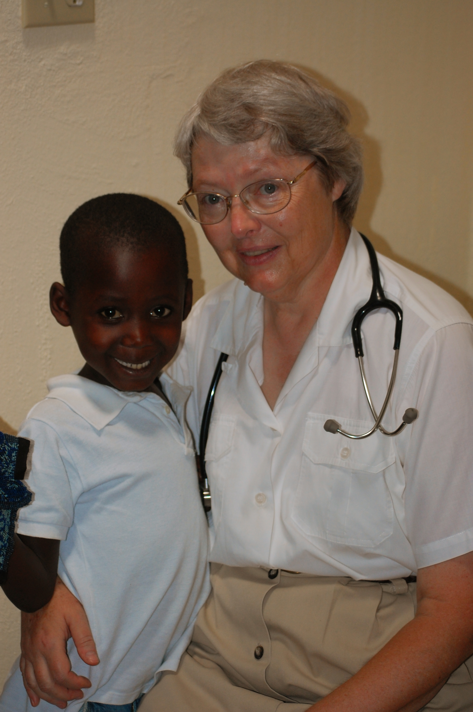
with
PO Box 2149
Decatur, AL 35602-2149
www.baptistworldmission.org

alivingston@baptistworldmission.org

My Testimony
I was born into a Christian family in the Detroit, Michigan, area. On Easter Sunday, at the age of seven, I heard the story of the death, burial, and resurrection of Jesus Christ. I understood that He died for my sins, and I needed Him as my Savior.

We attended a missions-minded church. The annual conference was always a special time. We also had missionaries in the church services during the year. I remember when Granny Holderman came to our church. She was a missionary in Haiti. My mother had shown the flannelgraph of Ti Fam and Granny in junior church. (It was more than 20 years later when I found out the child’s name meant “Little Woman”.) It was at our missionary conference when I was 12 years old that I dedicated my life for whatever God would have me to do.

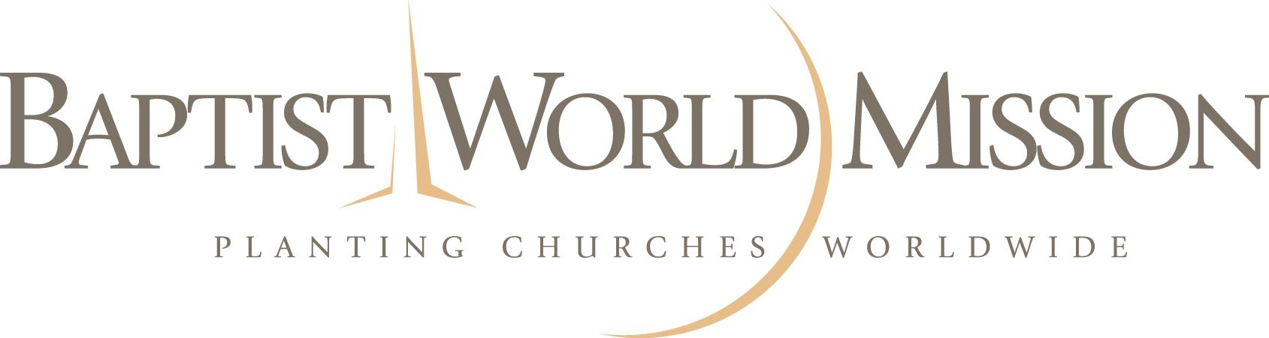
My undergraduate training was at Michigan State University, and I went to medical school at Wayne State University School of Medicine in Detroit. The summer between the third and fourth years of medical school was spent at a mission hospital in West Africa. That experience led to a residency in general surgery. About the time I was working to complete the process of board certification, I asked God for specific direction as to whether to work on a practice in the States or plan on full-time mission service. Within ten days, a missionary from northern Haiti talked to me about the needs in the location where he was serving. I made a survey trip and believed God was calling me to foreign mission service in St. Raphael, Haiti. Looking back, it turns out the church in St. Raphael started praying for a doctor about the same time as I dedicated my life—nearly 20 years earlier.

Ministry in Haiti
I arrived in Haiti in 1987 and learned the language—Haitian Creole. The following year we built the storage depot, dug the well, and made plans for buildings. We started the Gospel Baptist Clinic ministry in August 1989, and began the construction of the clinic building the following November. That building was completed in 2009.
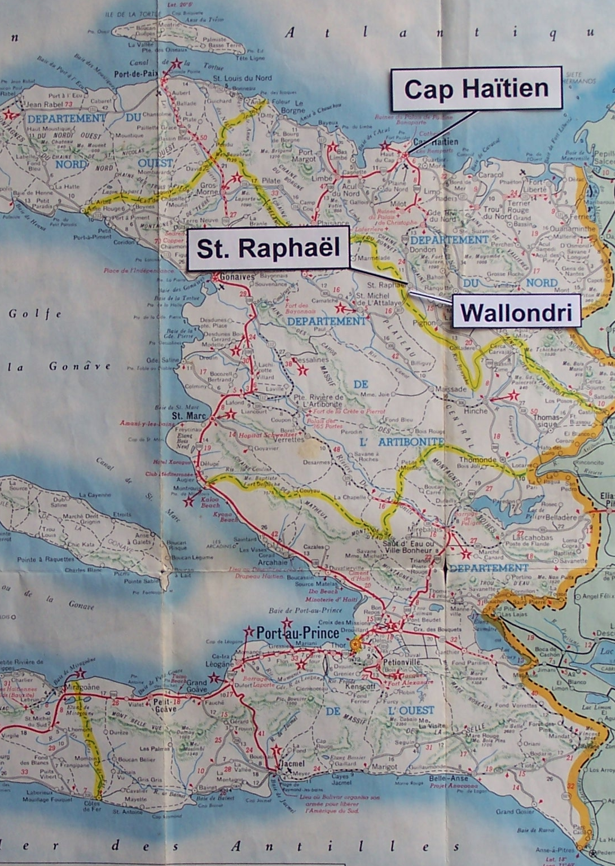
The presentation of the Gospel of Jesus Christ was the focus of the ministry. A national pastor preached before each clinic session, and we gave out literature and talked to patients individually. We used the ministry of medical care (which people need and want) to gain opportunities to proclaim the good news of salvation through personal faith in Jesus Christ. We were able to reach those who would never go to a sound church but need to hear the good news of the Gospel. That helped local pastors and church planters in their communities. We also encouraged the saints with affordable
medical care.

We cared for more than 13,000 people during the 20 years of ministry at the Gospel Baptist Clinic. Since family or friends often came with patients, we probably witnessed to more than 40,000 people. Patients came with many physical problems including malaria, typhoid fever, hypertension, heart disease, pneumonia, ear aches, and other infections. I was able to do some minor surgery.

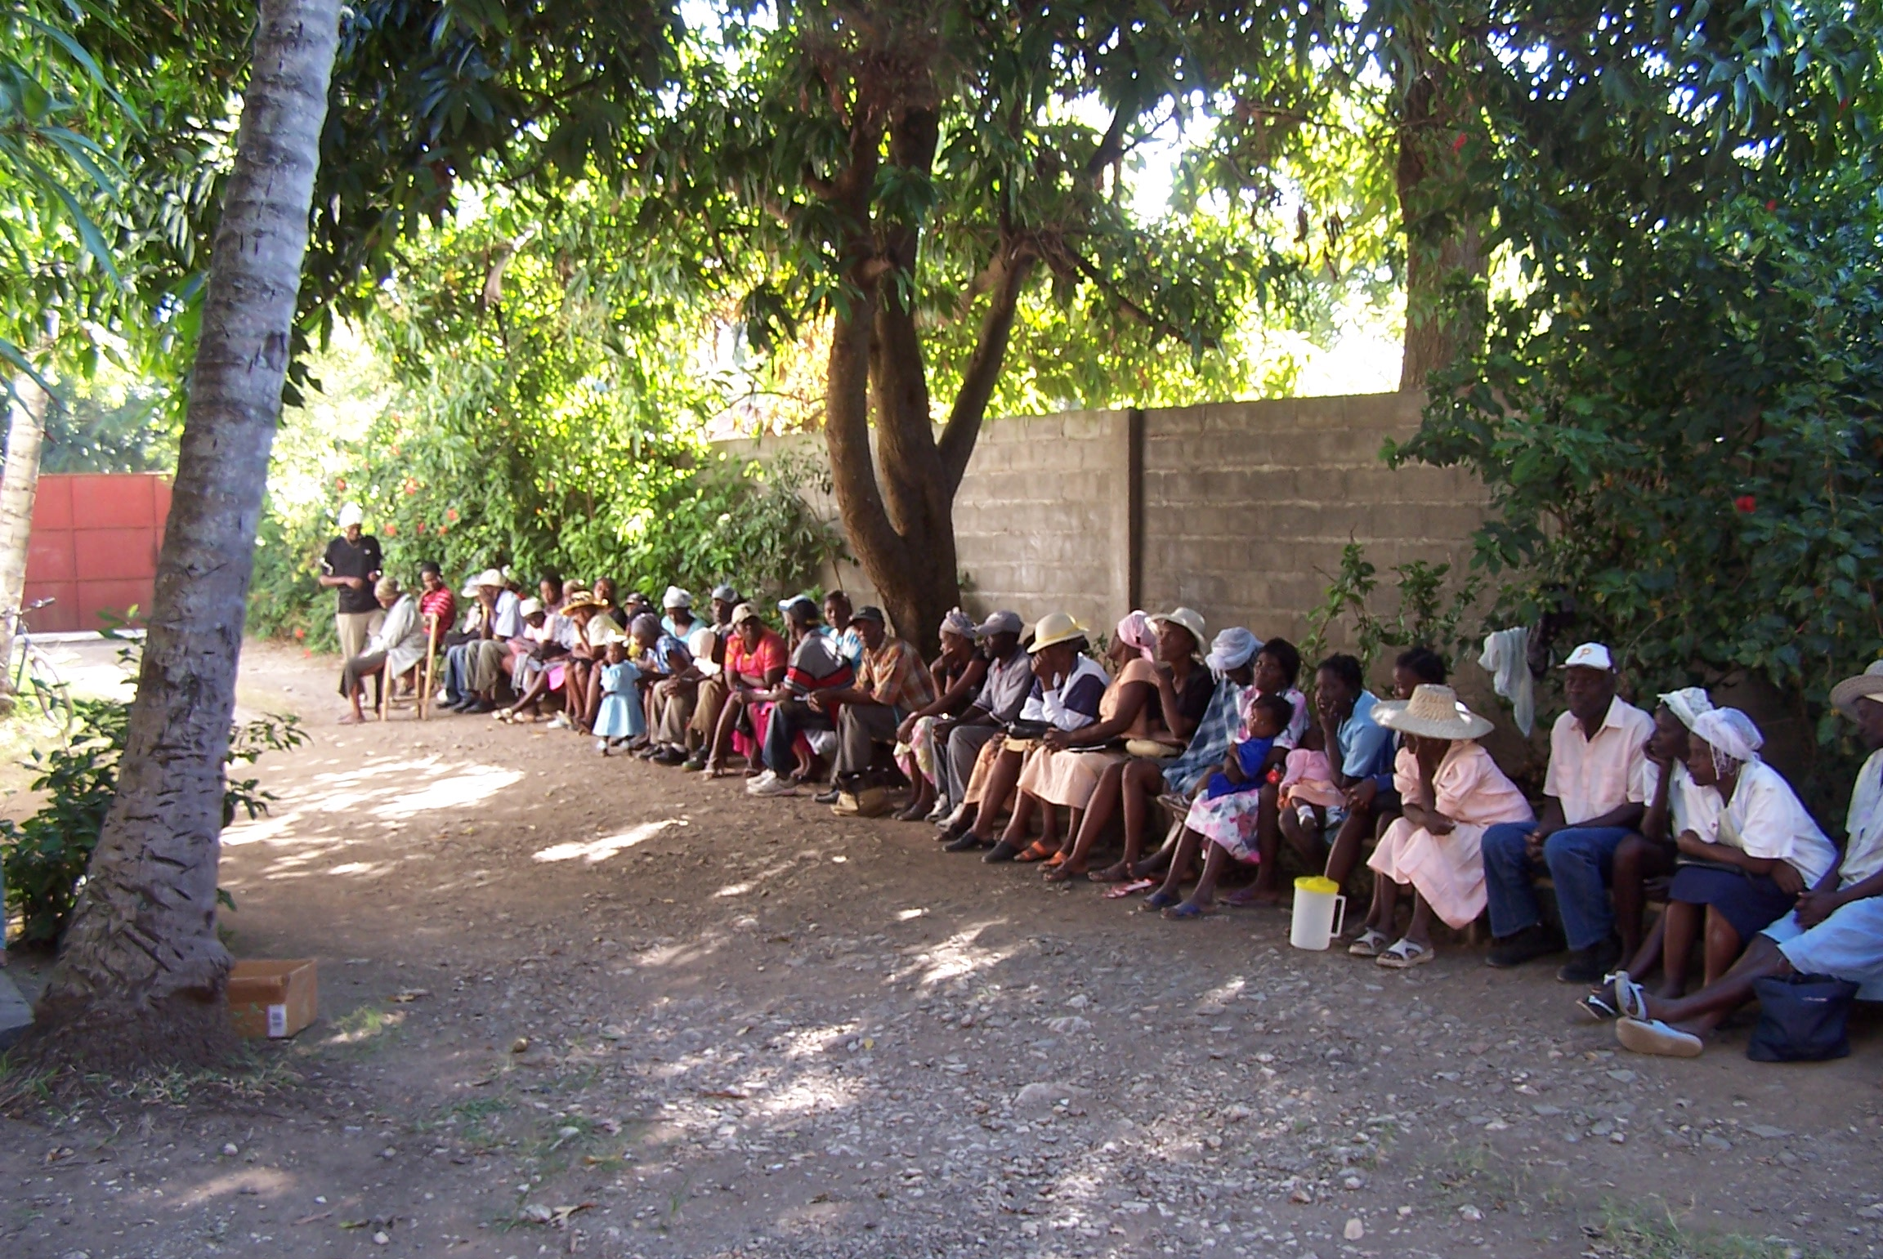
Another phase of that ministry was construction, including the clinic building, a guest house, and my house. This provided jobs for local people. One lady who was carrying water was saved after she heard the Gospel. She has continued faithful in church. The construction work was done by both Haitians and Americans. We had teams come to do special work such as electrical wiring. Those practical efforts meant quality work for our facility. It has been a blessing to learn that some of these men have gone on other teams to help with projects in the USA and abroad.

I hosted university students for several summers. Their majors were usually nursing or pre-med. I encouraged them to stay for at least six weeks to get an adequate view of foreign missions. The students helped in the clinic, studied Creole, took local “field trips,” and prepared a short vacation Bible school. In 2008 they also had a children’s time one afternoon a week. We completed a cross-cultural study book and worked through Tozer’s Attributes of God, a study that everyone agreed was very valuable. One of the students from 2006 said that the lesson he learned was that he had been making his own plans rather than looking to God to direct his paths.

In 2006 I completed the translation of a booklet on basics for believers, and two of my Haitian coworkers helped with the revision. I was finally able to get it printed in December 2008. That booklet has been useful as a tool for discipleship.

New Opportunities
I moved to nearby Wallondri and started the Grace Baptist Clinic in July 2009. The clinic workers from the previous ministry chose to continue working with me. From October to mid-December we saw 400 new patients, 1040 return-visit patients, 102 urgent patients, and did some minor surgery. We again placed emphasis on the Gospel, with preaching before the clinic and then handing out tracts and witnessing to individuals during the day. The year ended with the special blessing of a woman placing her faith in Christ after being treated for a severe infection.

New Affiliation and an Open Door
I was accepted by Baptist World Mission as an appointee to Haiti on April 20, 2010. My pastor, Dr. Drew Conley, and my home church, Hampton Park Baptist Church in Greenville, South Carolina, are very pleased about the ministry opportunities that are before me in Wallondri, Haiti. I am looking forward to providing medical care for people in the region and, at the same time, sharing the good news of salvation in Jesus Christ. The Haitian pastor and deacons of the local church are responsible for the preaching time at the clinic, as are the missionaries with whom I will work. They have already seen both the old and new clinics help their church-planting efforts. I am excited about the possibility of holding junior church again. Former students are interested in coming to help in the clinic. I am looking forward to what God will do for His glory!

Prayer Requests
- Remaining support so I can return to the ministry full time
- Wisdom as we consider projects
- The Haitian people need spiritual as well as physical healing. We at the clinic need to be faithful to deal with both of those needs.

And Jesus went forth, and saw a great multitude, and was moved with compassion toward them, and he healed their sick.
Matthew 14:14

